Panmure District School News

No.08 - Term.3, Week 08 –Monday 11 September 2017

Greetings, Kia ora, Talofa lava, Kia orana, Malo e lelei, Fakalofa Lahi Atu, Namaste, An Young Haseyo, Konichiwha, Bula Vinaka, Sawadee, Dobra Dan, Ni Hao, As-salamu alaykum, Hola

Tongan Language Week Celebration
!Malo ‘aupito! – Thank you to the family and friends for the wonderful week of Tongan language celebrations. We appreciate the support of our families who came with delicious food (taro, chop suey and otai) to share with the children as well as those who shared their knowledge of Tongan language and culture. We look forward to celebrating again next year!

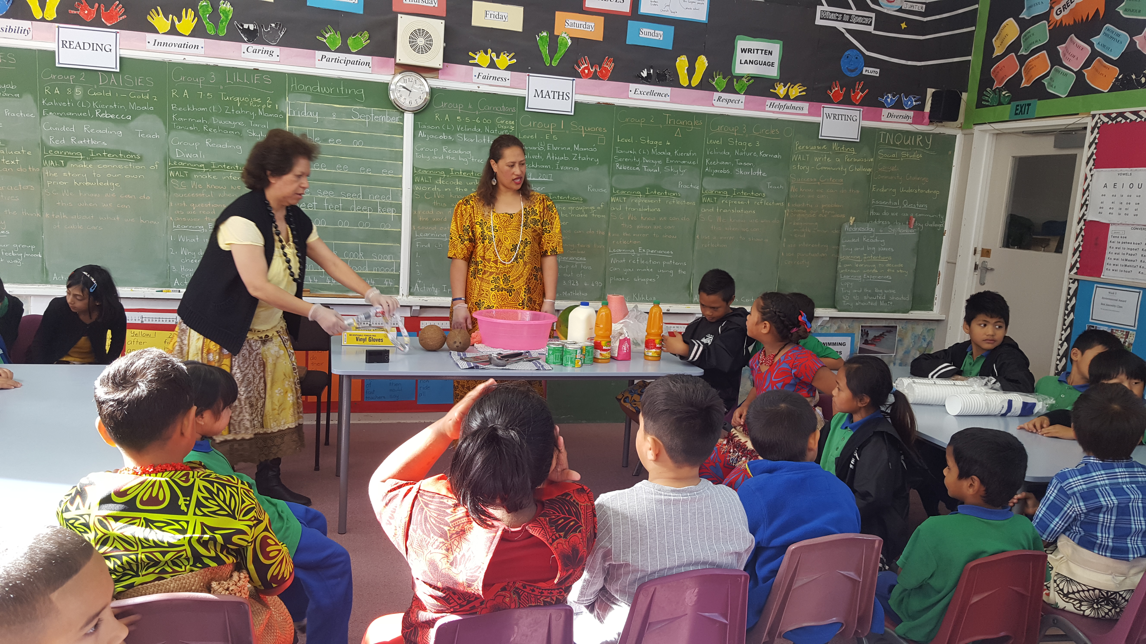

Maori Language Week
This week is te wiki o te reo Maori. Children will be learning some te reo and participating in Maori games. A reminder that children should be getting sponsors for our te - reo - a - thon happening this Friday. If you need more sponsorship forms please come to the office.


Squash
This is for our senior students in Rooms 3, 5 and 6. An exciting opportunity for our students to participate in and learn about squash.

Cultural Performance Evening
When: Next Thursday 21 September
Where: School Hall
Cost: Gold coin donation
During the performances, a bowl will be made available for donations to Panmure District School. We appreciate your support.


Panmure District School Baking Programme
The Baking Club is open for parents to come and show their amazing baking skills as well as mix and mingle with other parents. It starts at 9.00am every Wednesday in our school hall. All are welcome.

School Breakfast Club
The school runs the breakfast programme daily in the school hall at 8.30am for all children who are interested in having breakfast. Parents are welcome to come along.


Throat Swabs
Please note there is no longer free throat swabbing at some pharmacies and clinics. Please visit your doctor if a throat swab is needed. Children 13 years and under are free.

Upcoming Important Dates
Mufti Day fundraiser – Friday 22 September

Fijian Language will be celebrated in week 10 from Monday 25 September to Friday 29 September.

Duffy Assembly – Thursday 28 September

Term Dates - 2017
Term 3 finishes on Friday 29 September.
Term 4 starts on Monday 16 October
Term 4 finish on Thursday 14 December

Merit Awards
Room 3 –
Miracle Vaovasa for his interesting and descriptive narrative writing.
Niukasela Phillips for building the setting in her writing effectively.

Room 5 -
Teamo Atkins-Hooper for attending school regularly for the past two weeks.
Riwai Hooper for staying on tasks with little supervision.

Room 6 –
Chrysler Tauaneai for her fair play and great sportsmanship.
Ana Kaufusi for helping Mrs. Kumar translate English words into Tongan language.

Room 9 -
Ivanya Halolava for using word attack skills during reading.
Tayyab Faizi for showing a keen interest when reading in his group.

Room 10 -
Atiyab Chepuwala for confidently relating his personal experiences to stories read aloud.
Beckham Sok for working out mentally how many groups of tens there are in a 3 digit number up to 1000.

CONGRATULATIONS

Environmental Award – Mr Ashby
For looking after the school during Mr Newton’s absence.

Duffy Book Awards
Kartik Patel for trying hard to improve his writing skills.

Velinda Kaetau for great improvement in decoding new words in her story.

Elijah Kaisi for his enthusiastic work habits.

Benja Wanmontree for retelling the ideas, details and information from a text.

Marianne Ares for always rising to accept responsibility.

Anton Ameke for showing others how to be positive role models.


2017 Auckland Brick Show
New Zealand’s largest LEGO FAN DISPLAY at The Trust Arena in Henderson.

When: 21, 22 and 23 of October

Tickets: $7.00 per person if you pre-book them
Children under 3 are free

Door sales - $10.00 (subject to availability)

BUY YOUR TICKETS BEFORE 21 OCTOBER AND GO IN A DRAW TO WIN AN AMAZING LEGO PRIZE PACK WOTH OVER $500.
Mini Chef School Holiday Programme - OCTOBER 2017
Another school holiday programme for the upcoming school holidays. All of the courses are offered online, making them the perfect parent/child holiday experience! Whilst learning and having lots of fun, students will gain some great kitchen skills and learn new recipes along the way! There is no need to leave home, and at the end of the session, the Mini Chefs are guaranteed to have learnt some exciting new techniques!
There are two courses to choose from - Cooking or Baking! Both courses cover Hygiene, Food Safety, Production Schedules and Recipe Costing.
COOKING - Students will learn to make FRESH Homemade Pasta and a sauce, Parmesan Twists, Mystery Basket ingredients to make a dip, a main course and a dessert! They will also learn to make decorated Cupcakes and make their own Chocolate Moulds!
BAKING - This course will cover decorated Cakes, baking a Swiss Roll, create shaped, flavoured biscuits with decoration, Chocolate Mousse, Pavlova and/or Meringues and Parmesan Twists! All information is available at www.internationalculinarystudio.com

If you have any questions, please email cheryl@internationalculinarystudio.com

